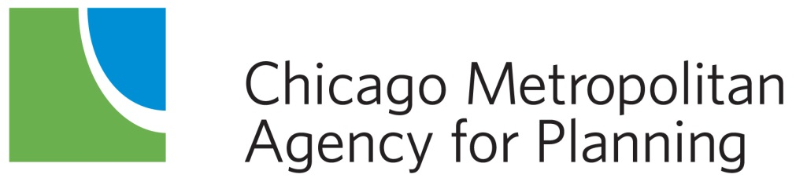

eTIP User Guide – STP-Shared Fund, CMAQ and TAP-L Call for Projects

January 2019

Table of Contents
Introduction 2
Accessing eTIP 3
Account Setup and Login 3
Navigating eTIP 6
Home Page 6
In Progress Applications 6
Contact CMAP or eTIP Help 7
CFP Tools Menu 7
My In Progress CFP List 7
My Accepted CFP List 7
My CFP List 7
Create/Amend CFP Projects 8
Log Out 8
Viewing Projects 9
Project Pages 9
Header Information 9
TIP Programming tab 11
Obligation tab 12
Map tab 12
Project IDs tab 12
Documents tab 12
Amendment History tab 13
Completing the Application Form 13
Data Field Types and Data Entry Tools 13
Project Information 15
Project Location 18
Proposed Funding Information 24
Schedule Info 29
Project Questions 31
Change Reason 36
Saving and Submitting Project Applications 36
Mapping Projects 37
Uploading Project Documents 40
Data Validation and Error Messages 41
Data Validation Errors 41
Server Errors 42
Additional Resources 43
Information for Current eTIP Users 44
Home Page: CFP project status 44
Project Tools: My CFP List 44
Starting a New Application 44
Reviewing and Submitting Applications 45
System Notifications 45

Introduction

The STP (FFY 2020-2024), CMAQ (FFY 2020-2024) and TAP-L (FFY 2020-2022) Call for Projects (CFP) will be completed online using the CFP module of CMAP’s eTIP database. Basic project and applicant information, including scope, location, contact, and requested funding, will be entered directly into the database. Applicants will use the eTIP mapping tool to “draw” their project (where applicable), and required and supplemental forms will be attached to the project within the database. Projects selected for funding will be transferred from the CFP module to the active TIP in October 2019.
The eTIP database requires applicants to establish login credentials, as described in this document, in order to submit applications. Staff or representatives of any agency eligible to apply for and receive STP, CMAQ or TAP-L funding may request credentials. Planning liaisons, CDOT, county, IDOT, and transit agency staff that are regular users of the eTIP database may use their existing login credentials to complete project applications.
Project applications completed by local sponsor agencies, such as suburban municipalities, townships, park districts, or forest preserve districts, require review by the appropriate Council of Mayors’ Planning Liaison (see list of municipalities by regional council for contact information). Only the Planning Liaisons will be able to submit completed local agency applications to CMAP.
For CDOT, Counties, IDOT, and Transit agencies, only regular eTIP users, with edit rights for their agency, will be able to submit applications directly to CMAP. CMAP staff suggests that applicants that are not one of these regular eTIP users meet with these users to discuss the submittal process and any internal deadlines for ensuring that completed applications are submitted to CMAP prior to the March deadline. Applicants that are unsure of the user(s) for their agency, or agencies wishing to extend edit rights to additional staff should contact Kama Dobbs (312-386-8710 or kdobbs@cmap.illinois.gov) or Doug Ferguson (312-386-8824 or dferguson@cmap.illinois.gov).

Accessing eTIP
This section serves to familiarize users with the layout and functionality of the eTIP database. To access the secure site, visit https://etip.cmap.illinois.gov/secure.

Account Setup and Login
Access to the eTIP database begins with the login screen. Returning users can simply login with the correct username and password. Usernames are not case-sensitive but passwords are. New users must first set up an account by clicking on the “Click Here” link as shown in Figure 1. The same link can be used to reset forgotten passwords.

Figure 1. Click the “Click Here” link to register for an account.
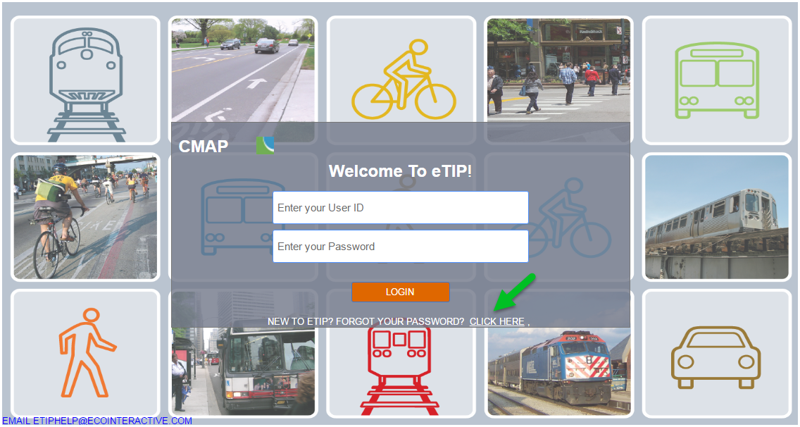

Next, users will be prompted to enter a valid email address and complete the Captcha verification as displayed in Figure 2. The Captcha verification tool provides options for users to regenerate a new image or to play audio if the original image cannot be seen clearly.
Figure 2. Enter a valid email address, type the text in the photo and click “Submit”.
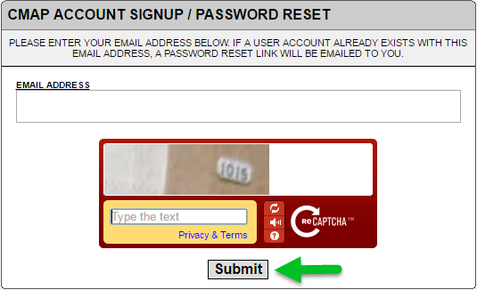

Next, users will be prompted to select a password, provide contact information and select their user type as shown in Figure 3.
- Enter a password, following the password requirements.
- In the “Name” field, be sure to enter your first and last name.
- Enter a 10-digit phone number.
- Select the appropriate agency from the drop-down list. The agencies listed are those that have edit rights to program and manage funding in eTIP. Local agency (municipalities, park districts, etc.) staff or their representatives should select the appropriate regional council as their agency.
*For users that may be completing applications for multiple local agencies, select “Not Available/Other” and email Kama Dobbs (kdobbs@cmap.illinois.gov) and Doug Ferguson (dferguson@cmap.illinois.gov) a list of agencies that you may be preparing applications for so that you can be granted access to multiple councils.
- Select the appropriate user type.
  - User types include CFP, read-only, sponsor, CMAP, and state, FHWA and FTA approval of TIP. For the call for projects (CFP), new users should select CFP as their user type.
  - For CDOT, County DOTs, IDOT, and transit agencies only: CFP users will not be able to submit applications directly to CMAP. Only users with edit rights for an agency can submit. To obtain edit rights, select sponsor as your user type. CMAP staff will verify requests for additional edit rights with existing users from your agency.
Figure 3. Complete the new user form, making sure to follow the password requirements, and click “Submit New User Information”.
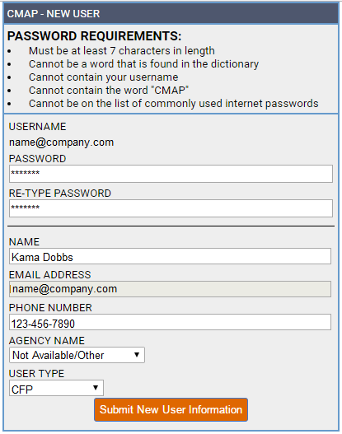
New users will receive an email indicating they have successfully submitted a request for a user account. Click the link in the email to verify the address. After the verification, CMAP staff will be notified of the request. Although CMAP staff will attempt to review user requests as soon as possible, it may take up to three business days for CMAP staff to review and approve accounts. Once approved, users will receive an email indicating the request for access has been approved and the user will be able to log in.

Navigating eTIP
Navigation throughout the eTIP database is accomplished using the menu bars at the top of each page. The menu choices vary by user level and the figures presented here illustrate the view of CFP users. Other users should refer to the Information for Current eTIP Users section of this document. The top menu bar remains at the top of the page in every page view and its menu items are explained in Figure 4.
Figure 4. Hover the mouse over items in the top menu bar to reveal the next menu levels.
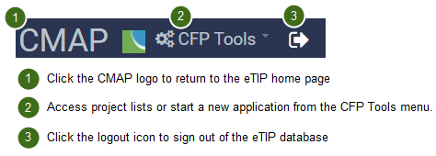

Home Page
The home page provides an at-a-glance summary of the status of the user’s applications. Applications that are “In Progress” are listed individually. The summary bar above the list also displays the number of the user’s projects that have been submitted to CMAP, and the number of projects that have been denied by CMAP, as illustrated in Figure 5 below. Return to this list at any time by clicking on the CMAP logo, or selecting “My In Progress CFP List” from the CFP Tools menu.
Figure 5. CFP Home Page Displays In Progress Applications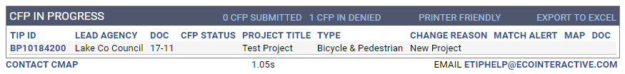

In Progress Applications
Applications that have been started and saved, but not yet submitted to CMAP for review, are considered to be In Progress. In progress applications that have been submitted for Planning Liaison review, but not yet submitted to CMAP, will have a CFP Status of “Save As Final”. To review and/or edit a pending application prior to saving as final, click on the ID link to open the most recently saved version of the project. Note, once saved as final, only planning liaisons and CMAP staff can release an application for additional changes. If you are a CFP user and need to make changes to your application prior to submittal to CMAP, please contact your planning liaison(s). Once released, the CFP Status will be “Unsubmit Final”.

CFP Submitted
From the home page, click on “CFP Submitted” to view a list of applications that have been reviewed by your planning liaison(s) and submitted to CMAP. Submitted changes are read-only. To view a submitted application, click on the ID link. In order to un-submit an application, CFP users must contact their planning liaison(s). If not re-submitted by the planning liaison prior to the application deadline, the application will not be considered for funding.

CFP In Denied
From the home page, click on “In Denied (CFP)” to view a list of applications that have been submitted to CMAP staff, but denied. The list will include the reason for denial. Prior to the final application deadline, applicants may attempt to address denial comments. Please contact your planning liaison(s) to release the project for editing.

Contact CMAP or eTIP Help
At the bottom of the home page are links to contact CMAP and eTIP help. For project-specific or procedural questions, contact CMAP. For technical issues, such as broken links and server error messages, contact eTIP help.

CFP Tools Menu
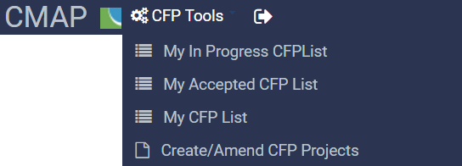

My In Progress CFP List
Selecting “My In Progress CFP List” will return users to the home page list of applications in progress.

My Accepted CFP List
A list of applications which have been accepted by CMAP for funding consideration can be viewed here.

My CFP List
A complete list of the user’s applications, regardless of status, is displayed as in Figure 6, including each project’s ID, Lead Agency (Programming Lead), Application Status (icons), Title, Project Type, Exempt Status, Total Cost, and indicators (icons) of associated maps and documents. Above the list is an advanced search box, from which the user can search for projects by a variety of fields.
Figure 6. My CFP list contains all projects for which the user has saved or submitted an application and is searchable by using the search tool at the top of the page.
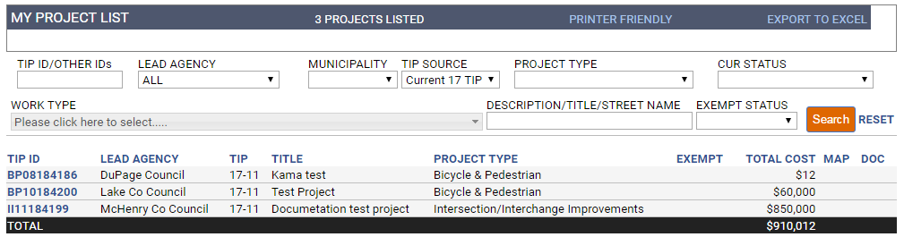
To view project details for a listed project, simply click on the project’s ID link. Status icons are as described in Figure 7.
Figure 7. My CFP project status icons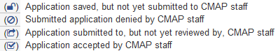

Create/Amend CFP Projects
To begin a new application select Create/Amend CFP Projects, then select “Create New Project” to start a new application with a blank form.

Log Out
By clicking the “Log Out” icon, users are logged out of the database and redirected to the login page.

Viewing Projects

Project Pages
Once a new application has been created, and an ID assigned by saving the application in progress, additional “tabs” are available to the user, as shown in Figure 9 on the following page. Users can navigate from one tab to another without losing changes made on other tabs, however, information on each tab must be saved using the save button on that tab to retain the changes before navigating away from the project application to any other menu item, such as the home page or My CFP List.

Header Information
Header information is shown in blue at the top of all project pages.
Figure 8. Project header

TIP (Project Application) ID (autogenerated)
The TIP (Project Application) ID is the unique identification number for the project within the TIP database. During the application process, the TIP ID field will be populated with the Project Application ID. If selected for funding, a project’s application ID will be converted to a TIP ID. These IDs are autogenerated based on the Application Type, Programming Lead Agency, County, and Municipality in which the project is located.

Version
The history of changes to projects is controlled and documented using "versions". New applications will be version 1 of the project. Additional versions will be created if a project is selected for funding. The version is displayed at the top of the project detail page.

Status
The status of a project changes over its life from project entry into the eTIP database to the project being built. The status in the header information of a project indicates its current program status.

Last Modified
The user who last modified the project and date of the last project modification are displayed in the header information of the project page. To contact the user who last modified the project, simply click on the user’s name to access the user’s contact information.
Figure 9. A project’s information is stored on multiple tabs of the project page.
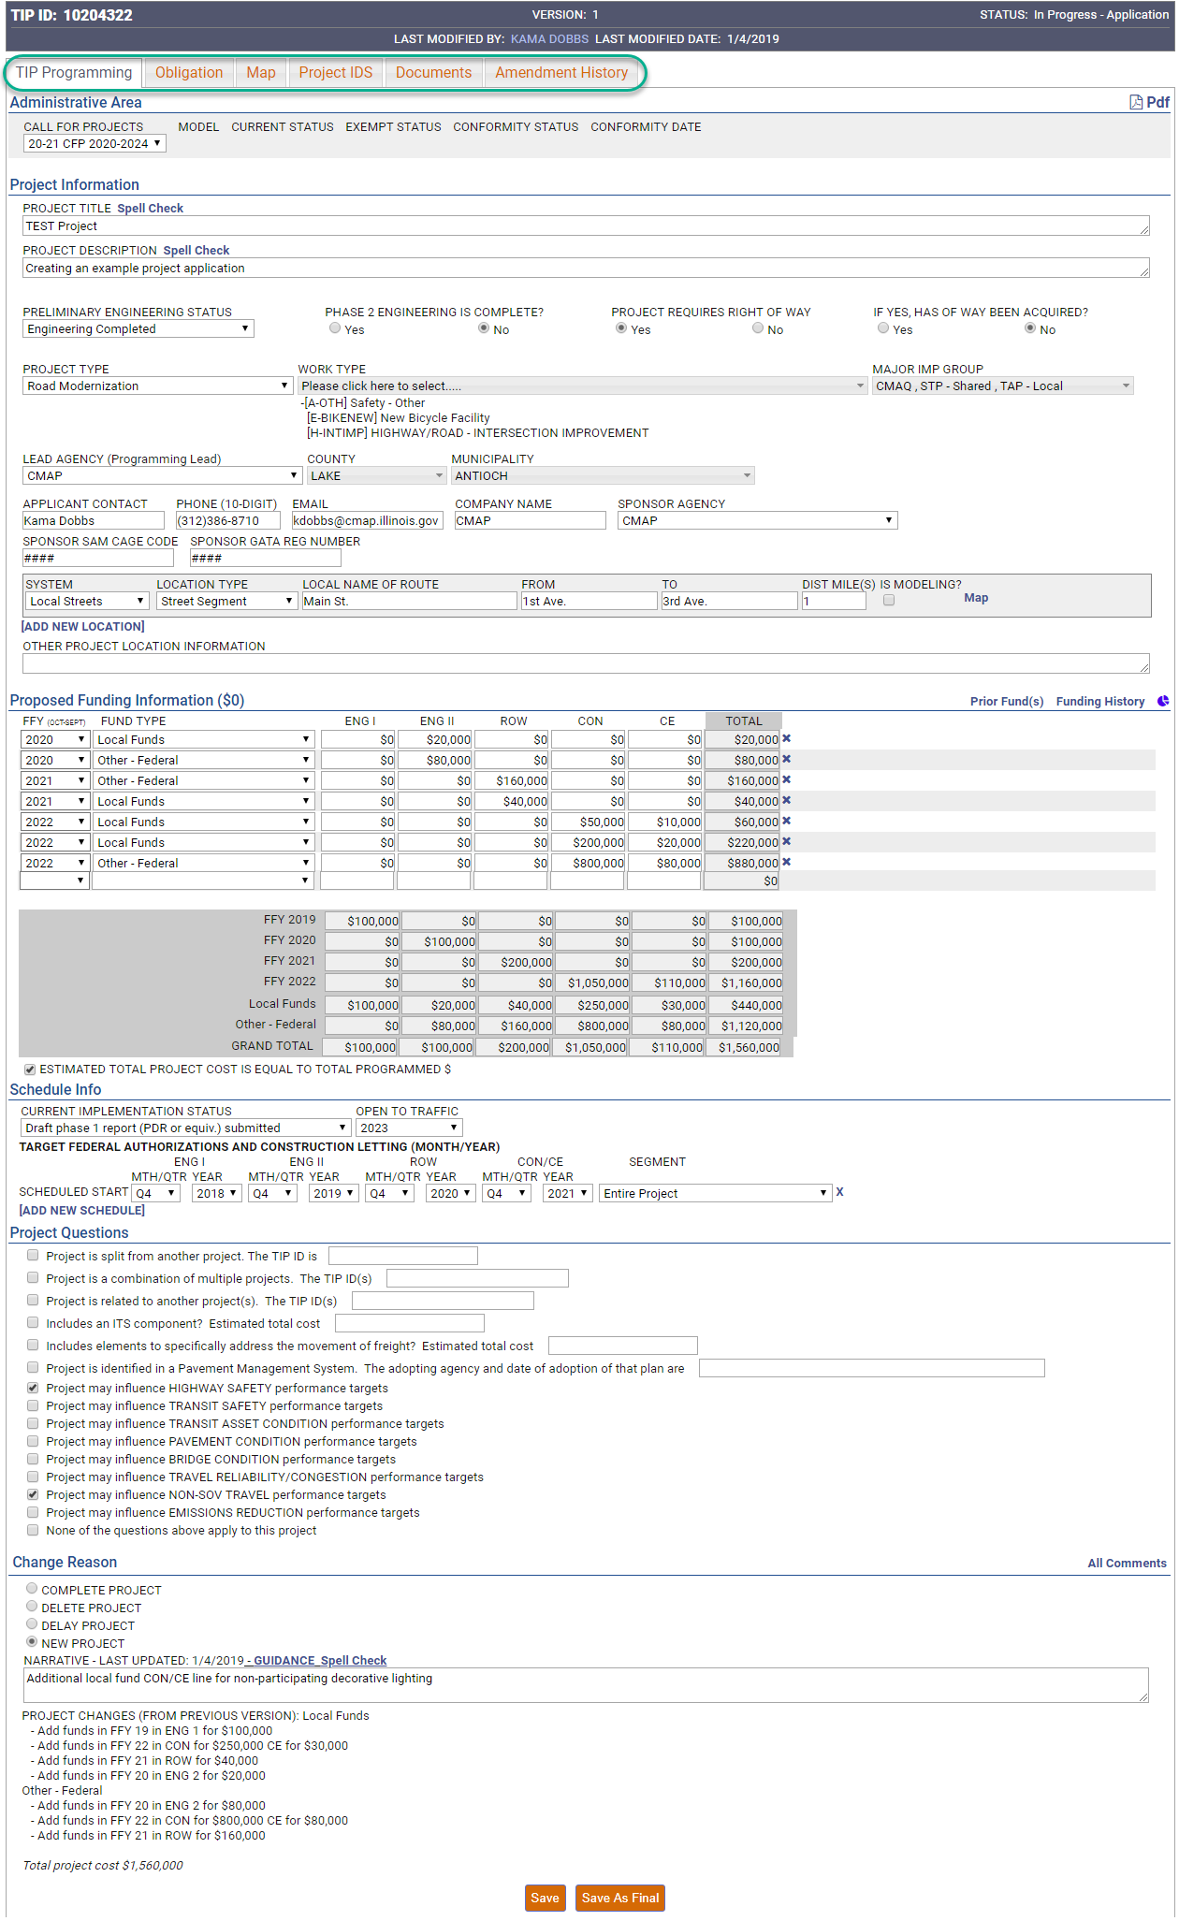

TIP Programming tab
The main tab for viewing and changing project application information and for saving and submitting applications is the TIP Programming tab. Descriptions of the fields and instructions for data entry are provided in the Completing the Application Form section of this document.

Alerts
Below the header information, users may see a banner indicating the status of the version of the project they are currently viewing, as shown in Figure 10. If there are errors that need resolution prior to submitting an application, they will be displayed here.
Figure 10. Alerts about a project’s status and error messages will appear in a yellow box under the project’s header information.

Administrative Area
Shown in Figure 11, the administrative area of the project form is editable only by CMAP staff. It indicates the application cycle that the project version displayed is a part of and the proejct’s status related to air quality conformity.
Figure 11. The administrative area contains information related to the region’s air quality conformity model in addition to TIP adoption/amendment and program information.

Project Information
The project information area of the project form contains basic project information including the project title, description, and status, the application type, project type and specific work types, contact and sponsor information, and location information.

Proposed Funding Information
All of the proposed funding for the project and the project’s total cost is displayed in the proposed funding information area.

Schedule Info
The Schedule Information section captures the current implementation status of the project and the target date (month/year) for construction letting, federal authorization of non-construction phases, or the start of non-federally funded phases.

Project Questions
A series of questions provide information about related projects, project elements that are important to the implementation of ON TO 2050, and the influence a project may have on federal performance targets.

Change Reason
For the call for projects, all applications will display a change reason of “New Project”. Narrative information that supplements the application may also be displayed here.

Obligation tab
If selected for funding, this tab will track federal funding obligations throughout the life of the projects. During the application process, this tab will be blank.

Map tab
Applicants are responsible for mapping project locations, with assistance, review, and correction by planning liaisons or CMAP staff. The mapping application uses Google Maps as a base layer with IDOT's Illinois Road Information System (IRIS) and Illinois Structure Information System (ISIS) files, CMAP's regional off-road bikeway network, CTA and Metra train lines, and CREATE Corridors overlaid for TIP project location mapping. An example of a mapped bicycle project is shown in Figure 12. Detailed instructions for mapping projects are provided later in this document. Mapped projects are converted to shapefiles for GIS analysis.
Figure 12. The Map tab allows users to map projects by selecting a transit, road or bikeway segment.
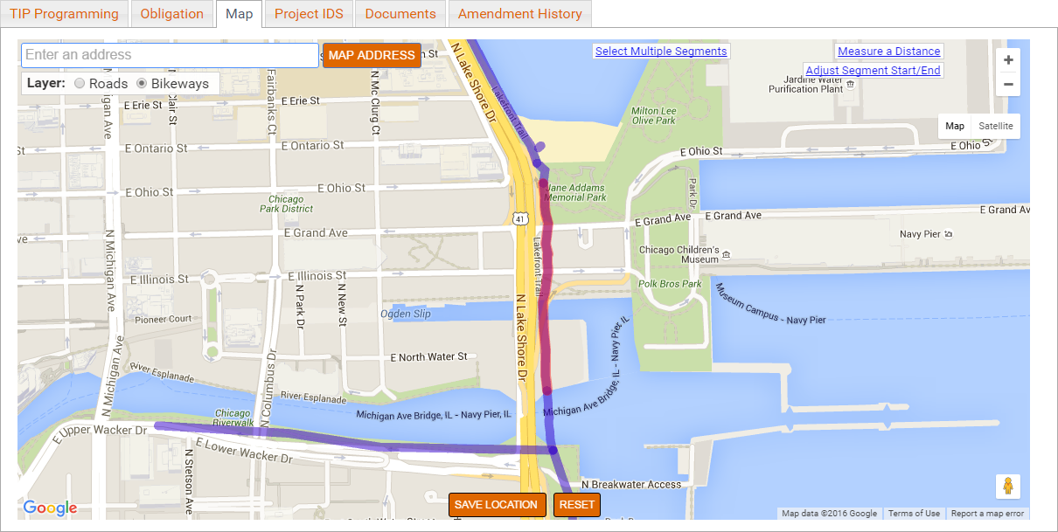

Project IDs tab
If selected for funding, several ID numbers will be assigned over the life of the project. The Project IDs tab provides a simple method of entering ID numbers. In most cases, these IDs will not be assigned until funding is secured and this tab will remain blank.

Documents tab
The Documents page is used to upload and display documents associated with the project, including forms required to apply for STP, CMAQ and TAP funding. Detailed instructions for uploading documents are provided in the Uploading Project Documents section of this document.

Amendment History tab
The history of changes to projects is controlled and documented using "versions". The Amendment History tab displays a log of versions from project creation within eTIP to completion. New applications will not have a history.

Completing the Application Form
When starting a new application, only the TIP Programming tab of the project page will be available, as shown in Figure 13. The types of data fields, data entry tools, and fields included in each section of the form are described in detail in below. Once the Project Information section is complete, applicants should click on the “Save” button at the bottom of the form to save their work, check for errors, and establish a project ID. Doing so will also make the Map, Documents, and other “tabs”, described earlier in this document, available for use.

Data Field Types and Data Entry Tools
In eTIP, data entry is structured via the use of several different types of fields, including many pre-populated drop-down lists, which provide consistent data entry and limit data errors. Flexibility is built in to accommodate the need for different data to be collected that is specific to the type and location of projects.

Text Boxes
Any text can be entered in a text box. The size of the box on the screen generally indicates the amount of detail that should be provided. Some text boxes, such as funding fields, may automatically format the entered text. Note that any text box with two dash marks in the bottom right corner may be expanded by clicking on that corner, holding, and dragging down to the desired size. Project title and description, contact information, select location fields, select financial fields, and change narrative are examples of text box fields.

Drop-down Lists – Single Value
These fields contain lists of valid values for the field and allow for a single value to be chosen, such as a project type or federal fiscal year. Selecting from a list of valid values is important for triggering other database actions. For example, when entering project location information, users will first indicate the system on which the project is located (local streets, numbered routes, transit, etc.) and the type of location (bridge, intersection, street segment, bus route, train station, etc.) appropriate to the project, so that corresponding data (from/to for segments, at for intersections, etc.) is requested. Clicking on the down arrow will reveal the choices. Users may select a value in these fields by typing the first few letters of the selection. Application type, select location fields, and select financial fields are examples of single value drop-down lists.
Figure 13. New Project Form.
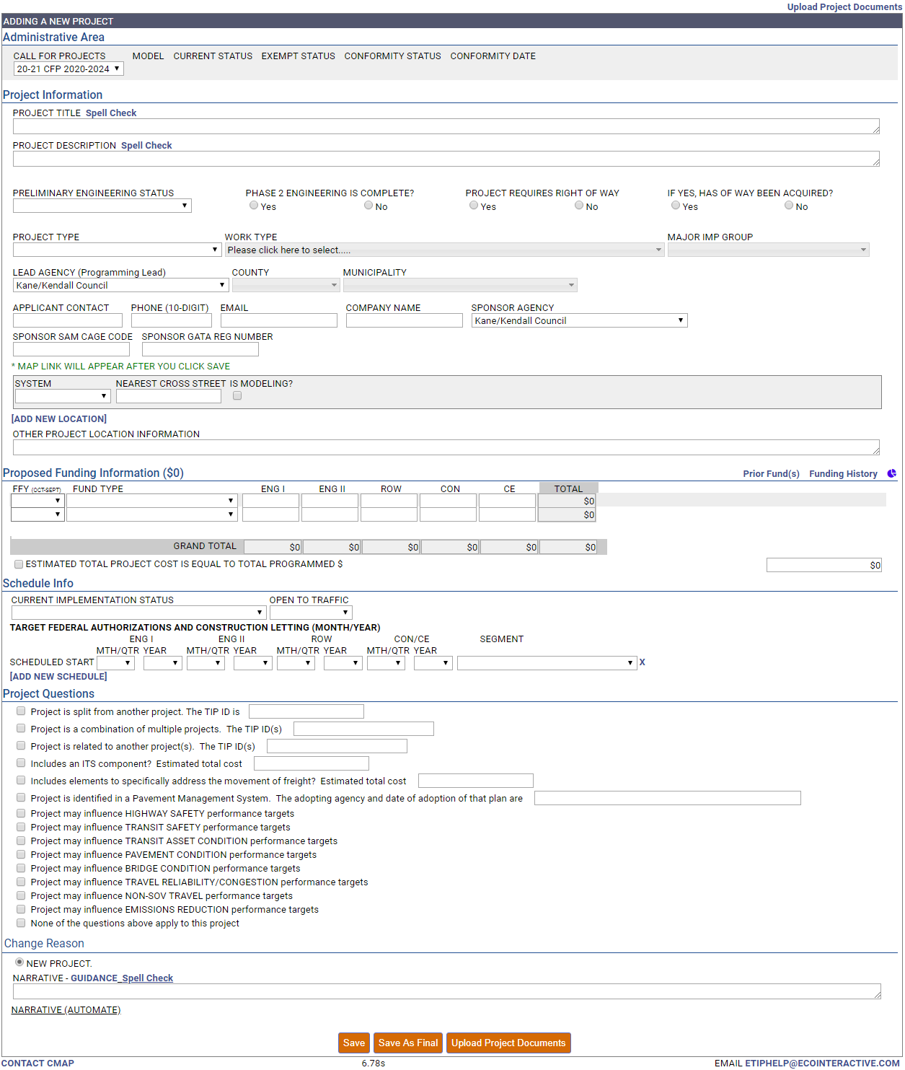

Drop-down Lists – Multi-select
Drop-down menus where multiple selections can be made (such as municipalities) have check boxes, and values are grouped within many of the drop-downs (such as fund sources, which are grouped as federal, state, local, or other). Clicking on the down arrow will reveal the choices. An unlimited number of values can be selected by checking all appropriate boxes and each choice must be manually selected by clicking the individual box. After moving to the next data field, selections will be displayed in the field, and can be edited by clicking the down arrow to expand the list. Work types, county, and municipality are examples of multi-select drop-down lists.

Check Boxes
Fields which use yes/no or true/false options, such as indicating that a public contact is the same as a primary contact, use a check box. Simply click in the box to check or uncheck the field. Status questions and total cost are examples of check box fields.

Spell Check
Text boxes requiring lengthy information or information that is often displayed on reports and the public site have a spell check tool for convenience.

Links
Within the project form, there are links to other information that may be helpful to users, such as “Add New Location” which will reveal an additional set of location fields. Links will be underlined when hovered over with a mouse, indicating the text is clickable.

Icons
Certain icons are used in lieu of text links throughout the database. For example, the delete icon () is used to clear information from financial lines. The cloud icon () is used to open a window for uploading documents.

Project Information
This section includes basic project information including the project title and description, the application type, status information, overall project type and specific work types, and contact information, as shown in Figure 14.
Figure 14. Project information includes a description and work types as well as contact information for the project programmer. 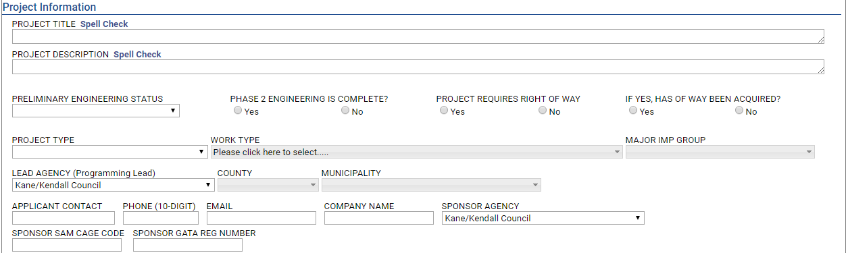

Project Title (required)
Enter a short, public friendly title that, when displayed to the public alongside the project description, should clearly and concisely describe the where or what of the project. The title entered should generally match the project title that will be included on state and/or federal paperwork when the project is implemented. Click “Spell Check” after entering the project title to ensure spelling errors are corrected before proceeding.

Project Description (required)
Enter a brief (one sentence) description of the work being done on the project, such as "Add turn lanes, modernize traffic signal, and make ADA improvements." Click “Spell Check” after entering the project description to ensure spelling errors are corrected before proceeding. The description entered should be easily understood by the public. Lengthier narrative descriptions may be attached as separate documents, as described in the Uploading Project Documents section of this document.

Preliminary Engineering Status (required)
Select the status of Phase 1 or preliminary engineering from the drop-down list.

Phase 2 Engineering is Complete?
Indicate the status of Phase 2 (Design) Engineering.

Project Requires Right of Way?
Indicate if the project requires Right of Way.

If Yes, Has Right of Way Been Acquired?
Indicate the status of ROW acquisition.

Project Type (required)
Select the overall project type from the drop-down list. Project Type categories are intended to help CMAP, our partners, and the public understand the main focus of projects with multiple work types. Project Types are also used to summarize investments in the region and will provide a high level illustration of the region's progress toward meeting the policy goals of ON TO 2050 and subsequent regional plans.

Work Type (at least one selection required)
Work types are used to represent individual project scope elements. Select every work type that will be included in the project by checking the box next to the description. More detailed descriptions of the work types, including the mode (highway, transit, etc.) each is associated with, and whether each is exempt or not exempt from air quality conformity analysis is available here. More information on conformity requirements, including FAQs, is also available here.

Major Imp Group
Select one or more funding program(s) for which you are applying: CMAQ, STP – Shared, or TAP – Local. Do not make any other selections in this field.

Lead Agency (Programming Lead) (required; dictates autogenerated application and TIP IDs)
Select the agency that will be responsible for the programming of the project within the eTIP database. For transit agency projects and IDOT, the programming lead agency is typically the implementing agency. For local agency projects, including county, municipal, and park or forest preserve district projects, the programming lead agency for STP, CMAQ, and TAP is the regional Council of Mayors that the project sponsor participates in and/or the geographic location of the project. A lead agency, county and municipality must be selected prior to saving a new project application in order for a Project Application ID to be properly generated. See this list of municipalities by council if you are unsure of the correct lead agency to select. Note that the list of agencies is restricted to those associated with your user rights.

County (required; dictates autogenerated application and TIP ID)
Select one or more counties in which the project is located by checking the box next to the county name. For projects that are not at a single location, such as purchasing vehicles or activities at various locations, if the primary use/location will be within a single county, select that county, otherwise select “Regionwide”. A lead agency, county and municipality must be selected prior to saving a new project in order for a Project Application ID and TIP ID (if selected for funding) to be generated. If not assigned by lead agency, the Project Application ID and TIP ID will be assigned based on the first (alphabetic) county selected when the application is first saved.

Municipality (required; dictates autogenerated TIP ID)
Select one or more municipalities in which the project is located (not the sponsoring municipality) by checking the box next to the municipality name. For projects in unincorporated areas, select the township, park district, school district, forest preserve district, or "Unincorporated". The municipalities available for selection are limited to those within the county(s) selected. All locations that the project passes through should be selected so that the project is listed when public site users search for projects by municipality. A lead agency, county, and municipality must be selected prior to saving a new project in order for a Project Application ID and TIP ID (if selected for funding) to be generated. If not assigned by programming lead agency and/or county, the TIP ID will be assigned based on the first (alphabetic) municipality selected when the application is first saved.

Applicant Contact, Phone, Email, Company Name (required)
Enter the name, phone number e-mail address, and company (or agency) name of the person that is the primary contact for application information. The applicant contact should be the person that CMAP staff should call with questions about the application, and may be different than the person completing the application.

Sponsor Agency
Select the agency that will be the primary sponsor of the project. Each project may have only one primary sponsor. This is the agency that will execute agreements with IDOT or apply for an FTA grant to utilize STP, CMAQ or TAP funding. For Park Districts, Forest Preserve Districts, or any other qualifying sponsor agency that is not listed, please select “Not Available/Other” and enter the Sponsor Agency in the Narrative field at the bottom of the form. For projects with multiple partners (particularly STP-Shared projects), enter the other participating partners in the Narrative field at the bottom of the form. Attach letters of funding commitment from the partners on the Documents tab.

Sponsor SAM Cage Code
Enter the System for Award Management (SAM) Commercial and Government Entity (Cage) code for the primary sponsor agency that will enter into funding agreements with IDOT for the project. For projects that will be implemented through an FTA grant, please enter “N/A”.

Sponsor GATA Reg Number
Enter the Grant Accountability and Transparency Act (GATA) registration number for the primary sponsor agency that will enter into funding agreements with IDOT for the project. For projects that will be implemented through an FTA grant, please enter “N/A”. GATA registration can be completed by accessing, completing and submitting the following Grantee Registration form: https://grants.illinois.gov/registration.

Project Location
The location portion of the Project Information section includes data required to locate projects within the region and to model projects subject to conformity analysis. Avoid using “and” or “also” in location names. Instead, for projects that involve multiple locations, such as distinct roadway segments, a series of intersections, or several bus routes or train lines, each distinct location should be entered as a separate line. For projects that involve modelling for conformity determinations, if the characteristics (such as number of lanes, or speed limit) change along the length of the project, those distinct segments should be entered as separate lines, as described later under the “Is Modeling?” heading.
Figure 15. Enter multiple locations or location types on separate lines.
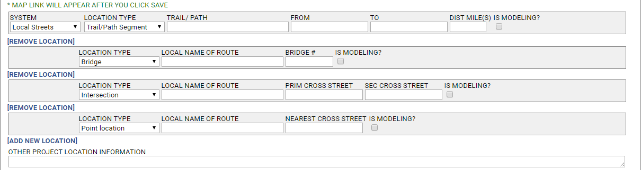
System (required)
Select the appropriate system from the list. The system selected not only affects the remaining location fields that will be available, but also which phase fields will be available in the Programming Information and Schedule Info sections of the project form.
- Highway/# Road
  - Projects on any road with an interstate, US, state, or county route number (township routes and FAU routes are not included).
  - Available phases will be ENG I, ENG II, ROW, CON, and CE.
- Local Streets
  - Projects on all other roads or on- or off-street bicycle/pedestrian/trails.
  - Available phases will be ENG I, ENG II, ROW, CON, and CE.
- N/A
  - Projects that are not location specific that have phase 1 and/or phase 2 engineering and/or a construction phase.
  - Available phases will be ENG I, ENG II, ROW, CON, and CE.
  - Example – Transit agencies programming a project with traditional phase 1 and 2 engineering, right-of-way acquisition and construction phases should select “N/A” as the system. Selecting “Transit” will only make general engineering, construction, and implementation phases available for funding.

- Non-Infrastructure
  - Projects that are not location specific that have general engineering and/or implementation phases such as Safe Routes to School non-infrastructure projects and emissions reduction projects.
  - Available phases will be ENG, IMP, and CON.
  - Example – Planning Liaisons programming a project such as a SRTS education/enforcement project should select “Non-Infrastructure” as the system in order to make an implementation phase available for funding.
- Transit
  - Projects involving bus or rail (including freight) service, lines, stops, or support facilities.
  - Available phases will be ENG, IMP, and CON.
Location Type (required)
Select the appropriate location type from the list. Each system has different location type choices that affect the specific location information that is collected:
- Highway/# Road
  - Bridge
  - Highway Segment
  - Interchange
  - Intersection
  - Not Location Specific
  - Point Location
  - Various Locations
- Local Streets
  - Bridge
  - Intersection
  - Not Location Specific
  - Point Location
  - Street Segment
  - Trail/Path Segment
  - Various Locations
- Transit
  - CTA – Bus Route, Bus Stop, Garage, Other Support Facility, Terminal, Train Line, Train Station, Yard
  - Metra – Garage, Other Support Facility, Terminal, Train Line, Train Station, Yard
  - Pace – Bus Route, Bus Stop, Garage, Other Support Facility, Park-N-Ride, Terminal, Yard
  - Other Rail – CREATE Corridor, Other Freight/Private
  - Other Transit – Not Location Specific, Other Transit
- Non-Infrastructure
  - Education/Enforcement
  - Emissions Reduction
  - Other
  - Traffic Control/Management
Location Fields
The fields available for location information vary by the System and Location Type selected. All possible fields are described below. The System/Location Types that they apply to are noted.
- Route
Select the route number the project is located on.
  - I/US/IL/CH – highways that have multiple designations
  - I – Interstate
  - US – US Highway
  - IL – State Route
  - CH – County Highway
Please contact CMAP staff if you believe a route is missing from the list.
Applies to: Highway/# Road System (required)
- Local Name of Route
For Highway/# Road, enter the local name of the primary location of the project. For example, US 14 is known locally in Cary as Northwest Highway. If there is no local name for a numbered route, leave this field blank. For Local Streets, indicate the street name of the primary location of project. For projects processed through IDOT Local Roads, the name should match all IDOT paperwork (PPI form, PDR title, etc.). Remember that for projects that involve multiple locations, such as distinct roadway segments, a series of intersections, or several bus routes or train lines, each distinct location should be described as a separate line.
Applies to: All location types on the Highway/# Road System (optional); Bridge, Not Location Specific, Point Location, Street Segment and Various Locations types on the Local Streets System (required)

- Bridge #
Enter the IDOT structure number of the bridge associated with the project. If more than one structure is included in the project, list each one on a separate location line. Note, structure numbers can be found using IDOT's Bridge Information System Search page. It is best to select the City or County in which the structure is located, and then pan/zoom to the project location to find the correct structure.
Applies to: Bridge location types on the Highway/# Road System or Local Streets System (required)
- From
Enter the cross street that is at the northern or western end of the project. The “street” can also be another geographic feature such as a river, rail line, or political boundary (village limits, county line, etc.).
Applies to: Hwy Segment location type on the Highway/# Road System (required); Street Segment and Trail/Path location types on the Local Streets System (required)
- To
Enter the cross street that is at the southern or eastern end of the project. The “street” can also be another geographic feature such as a river, rail line, or political boundary (village limits, county line, etc.).
Applies to: Hwy Segment location type on the Highway/# Road System (required); Street Segment and Trail/Path segment location types on the Local Streets System (required)
- Dist Mile(s)
Enter the length of the project in miles. The map application can be used to measure distances, as described later in this chapter.
Applies to: Hwy Segment location type on the Highway/#Road System (required); Street Segment and Trail/Path Segment on the Local Streets System (required)
- # Location(s)
Enter the approximate number of distinct locations where work will be done for projects with multiple locations that are not listed individually, such as filling sidewalk gaps within a geographic region.
Applies to: Various Locations type on Highway/# Road and Local Streets Systems (required)
- Cross Route
For interchanges of two numbered routes, enter the route number of the secondary route.
Applies to: Interchange location type on the Highway/# Road System (optional)
- Cross Street Name
For interchanges, enter the local name of the secondary route.
Applies to: Interchange location type on the Highway/# Road System (required)
- Cross Street
For intersections, enter the local name of the cross street.
Applies to Intersection location type on the Highway/# Road System (required)
- Nearest Cross Street
For locations along roadways that are not located at an intersection, enter the nearest cross street (or geographic feature) to the project location.
Applies to: Point location type on the Highway/# Road and Local Streets System (optional); All location types on the Transit System (optional)
- Prim Cross Street
Enter the primary cross street for an intersection.
Applies to: Intersection location type on the Local Streets System (required)
- Sec Cross Street
Enter the secondary cross street for an intersection.
Applies to: Intersection location type on the Local Streets System (required)
- Trail/Path
For trails/paths that are named (such as the Illinois Prairie Path or Fox River Trail), enter the trail name.
Applies to: Trail/Path Segment on the Local Streets system (required)
- Route/Location Description
For bus route, train line, and CREATE corridor location types on the transit system, select the route, line, or corridor (including "multiple routes", "new route" and "systemwide"). For all other location types on the Transit system, enter a description of the location in this field, such as the street a bus stop is located on, or the specific location of a yard, garage, or support facility.
Applies to: All location types on the Transit system (required)
Is Modeling?
All projects with Not Exempt or Exempt Tested Work Types are modeled (see Work Type information on the TIP Programmer Resources web page). If the model segment matches the project limits, the box should be checked and the model information completed. If the model segment differs from the overall project limits, or if the characteristics (such has speed limits) change within the project limits, users will need to add a new location for each distinct model segment, check the box, and complete the model information for each segment to be modeled. For example, in Figure 16, the number of lanes after the improvement changed.
Figure 16. Model segments that differ from the project limits
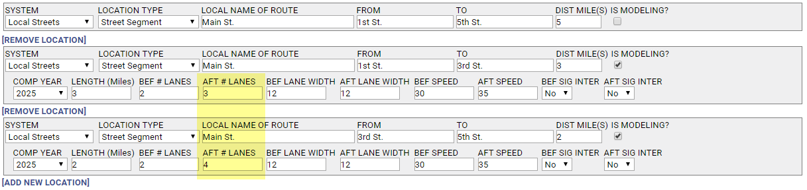
Link: Map
The “Map” link at the right of the location information section redirects the user to the map application, zoomed in to the location entered. For new projects, the map link will only be available after project information is saved for the first time. If a project cannot be mapped within eTIP, the user should attach a map in the documents tab.
Links: Add New Location / Remove Location
If there is more than one location for the project, click “[ADD NEW LOCATION]” to display another line for entering location information. Conversely, a “[REMOVE LOCATION]” option will appear if the user wishes to permanently delete the additional location. The first location listed can never be removed.
Other Location Information
Enter any other information about the project location that is not contained in the previous location fields, such as omissions within the limits.

Proposed Funding Information
The Proposed Funding Information section contains the detailed financial information about the project, as shown in Figure 17. The section includes the Estimated Total Project Cost field, which applies to the entire project, and a series of fields that apply to each financial line item.
Figure 17. Funds programmed in years prior to the current TIP years can be viewed/hidden by clicking “Prior Fund(s)”.
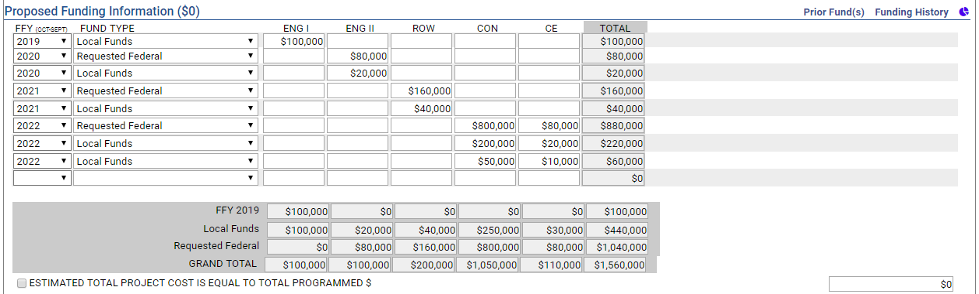

When applying for STP, CMAQ or TAP funding for a project, all phases of the project, and all fund sources being used must be included in the Proposed Funding Information section. The following should be considered prior to entering proposed funding information:
- All funding amounts are in actual whole dollars, not thousands ($000's).
- Each line of federal funding requires a corresponding line showing local match.
- Over match or non-participating items that will be funded with state or local funds should be included on a separate line.
- Construction Engineering must be entered separately from Construction, but can be entered on the same financial line if it is funded in the same year and with the same fund source as construction.
- Every fund source being utilized on a project, including state and local matching and non-matching funds, must be entered on its own line.
- Subtotals by line item, FFY, and fund source, as well as grand totals, will be calculated and displayed automatically.

When viewing proposed funding information, funds in years prior to 2020 will be hidden by default, making it easier to see and review what is proposed funding from 2020 - 2024. Those prior year funds can be viewed or hidden by clicking on the “Prior Fund(s)” link at the top of the funding table.

FFY (federal fiscal year)
Select the federal fiscal year (FFY) in which the line item will be authorized (for federal fund sources) or first expended (for state or local fund sources). The federal fiscal year is from October 1 (of the prior calendar year) to September 30. For any phases which were authorized prior to FFY 2015, include the year, fund source and amount of funds in the Narrative field at the bottom of the form. Remember to include these funds in the estimated total project cost.

Fund Type
Select the source of funds proposed for each line item. Select “Requested Federal” for the federal portion of the funds you are applying for. Do not select a specific fund source unless the funds have been secured, for example, STP-Locally Programmed funds from a Council. Attach documentation, such as an adopted Council STP project listing, demonstrating that the funds are secured. A description of current fund sources, including how they are distributed, who is responsible for programming and whether they are federal, state or local, is available on the TIP Programmer Resources page of the CMAP web site.

Transportation Development Credits (TDCs and TDCHs)
TDCs and TDCHs (also known as Toll Credits) are used to provide credit towards local match requirements for certain federally funded projects. When credits are used, the federal participation in a project is increased, typically to 100%. The credits themselves are not actual cash being spent on projects, and therefore they are not a part of the total project cost. However, the additional federal funds being used are a part of the total cost. Documenting the use of TDCs and TDCHs in the eTIP database is critical to understanding the magnitude of their use in the region and increases transparency to the public.

- TDCs and TDCHs are treated as a regular financial line item, however they are not included in the yearly totals or project grand total. Figure 18 illustrates the use of TDCs on a transit project. In this example, there are $2.5M in TDCs being used to match $9.2M in FTA 5337 funds in FFY 2016 ($2.5M + $9.2M = $11.7M), and $5M in TDCs matching $15M in FTA 5337 funds in FFY 2017 ($5M + $15M = $20M).
- To properly account for both the federal funds and TDCs or TDCHs proposed to be used for a project, the total amount of federal funds, including the TDCs or TDCHs, should be entered as a separate financial line item for each federal fiscal year (FFY), federal fund source, and phase.
- The TDCs or TDCHs proposed to be used to "match" each federal financial line item should be entered on a separate line item.
- The fund source for TDCs is "Trans Credit – Transit" and is found under the Local heading. The fund source for TDCHs is “Trans Credit – Local/State Highway” and is found under the Federal heading
Only transit agencies and CDOT can request the use of TDCs for CMAQ or TAP funded projects. Only eligible Cohort 4 municipalities or Chicago Community Areas, as defined in the 2019 Community Cohorts document may request TDCHs for STP – Shared funded projects. Further details on eligibility and use of TDCHs are available in the Policy for the use of TDCHs for STP funded projects.
Figure 18. Example use of TDCs (or TDCHs)
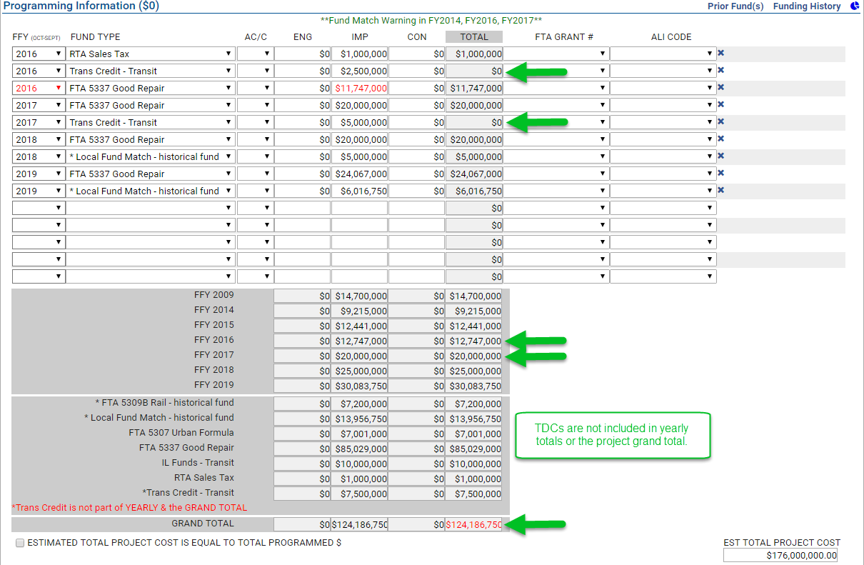

Phases (ENG I, ENG II, ROW, CON, CE, ENG, IMP)
Enter the cost for each line item (FFY and funds source) in the appropriate phase column in dollars.

For Highway/# Road, Local Streets, and N/A systems, the phases are:

- ENG I – preliminary engineering
- ENG II – design engineering
- ROW – right-of-way acquisition
- CON – construction
- CE – construction engineering

For Transit and Non-Infrastructure systems the phases are:

- ENG – pre-implementation studies or planning or preliminary and/or design engineering for construction projects
- IMP – implementation
- CON – construction

Total
The line item total is auto calculated.

Estimated total project cost is equal to total programmed $
Select this check box to indicate if the estimated total project cost (all phases and all fund sources, whether included in the TIP or not) is equal to the displayed grand total amount in eTIP. If they are not equal, such as when TDCs or TDCHs are used, or funds have been authorized prior to FFY 2015, do not check the box, and instead enter the total project cost manually.

Grouping Funding by Project Sections
For complex projects being implemented over multiple years or in segments or stages, or for projects with mixed funding that is designated for a specific portion of the overall project, users will be able to create "subprojects" called sections for managing the individual projects within a larger project. The intent of subprojects is to provide a way to identify the line items within a project that are implemented under different section IDs (roads), different FTA grants or service board projects (transit), or other logical "breaks" to be grouped together for more logical and comprehensive tracking.
Figure 19. Programming Information grouped by project sections
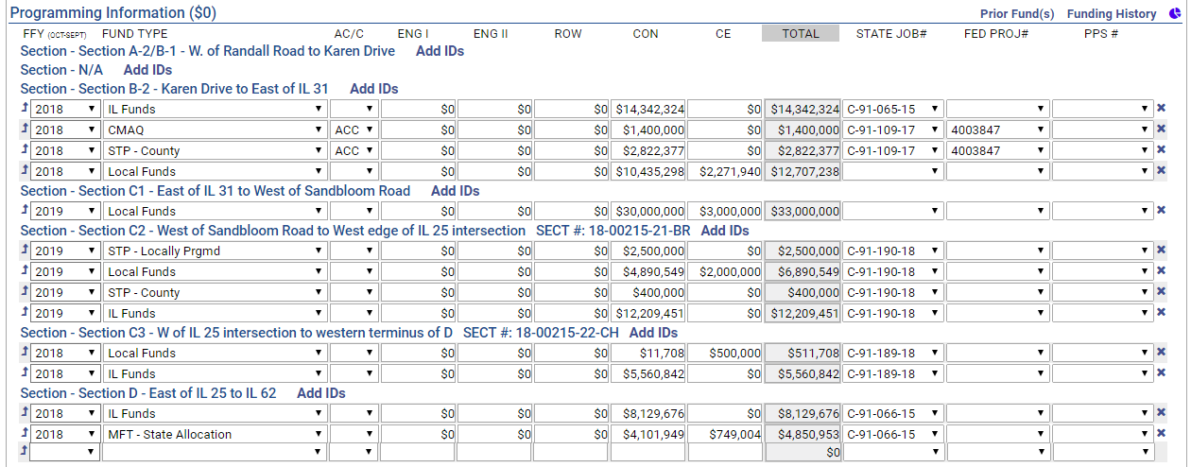
In order to organize fund line items into sections, the section titles must first be created in the Project IDs tab in the “Section Name” field, separated by commas, as illustrated in Figure 20.
Figure 20. Project IDs tab - Section Name
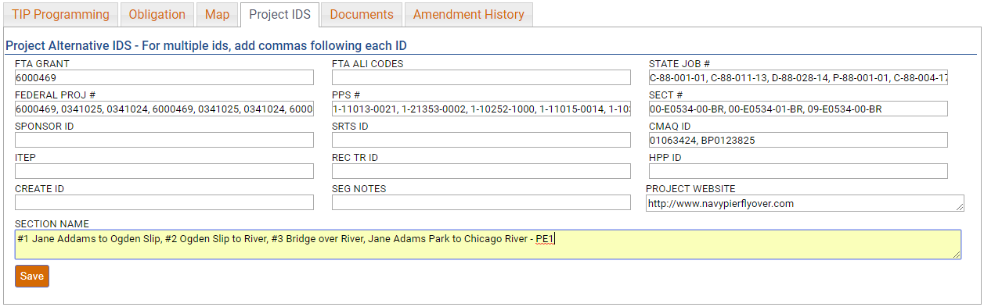
Upon clicking “Save”, the section names will be available for selection in the Programming Information section of the TIP Programming tab by clicking on the arrow icon () for each line item to be assigned to a section.
Figure 21. Programming Information - Adding project segments
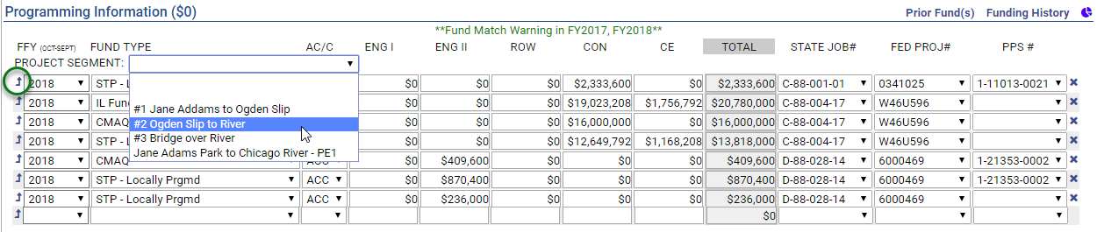
After saving the section assignments, additional identifiers may be added to each section, by clicking the Add IDs link.
Figure 22. Programming Information - Adding additional section IDs
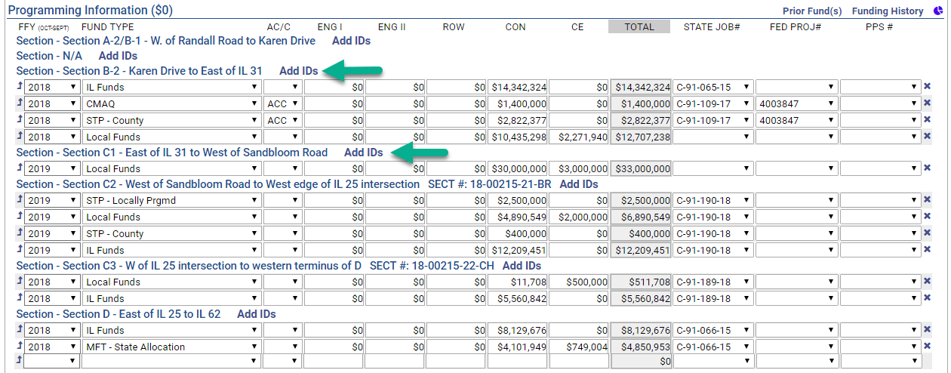

Schedule Info
The Schedule Information section captures the current implementation status of the project and the target date (month/year) for construction letting, federal authorization of non-construction phases, or the start of non-federally funded phases.
The phases for which schedule information is requested varies by the “system” selected for each project, and matches the phases for which funding information is requested, as shown in Figures 23 and 24.
Figure 23. Schedule Info - Highway/# Road, Local Streets, and N/A location types
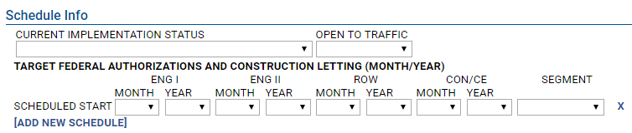
Figure 24. Schedule Info - Transit and Non-Infrastructure location types
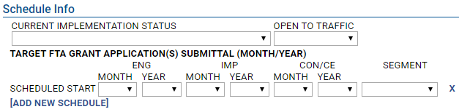
Current Implementation Status
Select the current status of the entire project from the drop-down list. The choices are generally arranged in the order they occur from “Project Scoping” to “Project Closed Out” for projects processed through IDOT/FHWA and from “Preparing FTA Grant Application” to “FTA Grant Closed Out” for projects processed through FTA.
Open to Traffic (required)
Select the calendar year in which the project will be complete, and open for public use. This information is required for all projects. The open to traffic year should be the same as the completion year for Not Exempt and Exempt Tested projects. For non-infrastructure projects, the open to traffic year should be the year in which the project will be implemented. For multi-year programs, the final year should be selected.
Scheduled Start Month/Year (required)
Select the Month and Year that each funded phase of the project is scheduled to start. In general, “start” means the date when funds are obligated or a contract or agreement to complete work is executed. A month and year are required for all phases with any funding in the current FFY. A year is requested for all funded phases, and should reflect the actual planned project schedule (calendar year), not the funding year, which may differ from the target year due to financial constraint or other programming considerations. In some cases, particularly non-federally funded engineering phases, a target month may be unknown. In these cases, the anticipated calendar year quarter (i.e. Q1 = January, February, or March, Q2 = April, May, or June, etc.) may be selected. Phases that began prior to January 2016 can be left blank. If a phase that began prior to 2016 is converted from AC to ACC (and thus moved into the current FFY), select the month/year of the conversion.

Segment
Select the segment to which the schedule information applies. In most cases, “Entire Project” will be selected, however for complex projects being implemented over multiple years or in segments or stages, select the appropriate segment. Click on the [ADD NEW SCHEDULE] link to add a schedule for each individual segment. For more information on creating segments, see the eTIP User Guide or the “Completing the TIP Programming Form” webinar. To delete a schedule section, click on the “X” to the right of the Segment field.

Project Questions
The Project Questions section is used to capture targeted information about projects, such as relationships to other TIP projects, inclusion of ITS or freight components, relationship to pavement management systems, and the project’s potential to influence federally required performance targets. At least one question must be selected for every project.
Figure 25. Project Questions
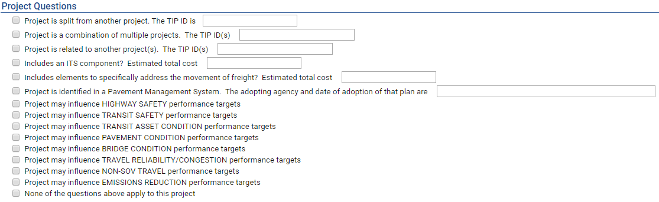

Relationship to other TIP Projects
The first three questions document a project’s relationship to other TIP projects.
- Project is split from another project. Select if the project was previously programmed under a different TIP ID and enter that TIP ID in the space provided.
- Project is a combination of multiple projects. Select if multiple projects were combined to create the current project and enter the TIP IDs of those projects in the space provided.
- Project is related to another project(s). Select if the project is part of a group of projects that were programmed separately but may be implemented together and enter the TIP ID(s) of the related project(s) in the space provided.

Included elements (ITS and Freight)
The next two questions are meant to capture the region’s investments in certain project types or elements that are not always evident in the overall description or programming.
- Includes an ITS component? Select if the project includes Intelligent Transportation System (ITS) components and enter the estimated cost of those components in the space provided.
- Includes elements to specifically address the movement of freight? Select if the project includes elements, such as larger turn radii, that are specifically intended to improve the movement of freight and enter the estimated cost of those elements in the space provided.

Pavement Management Systems
The next question is intended to provide a sense of how pavement management systems in use throughout the region may influence project selection and programming.
- Project is identified in a Pavement Management System. Select if the project location and scope of work were identified in any Pavement Management System, and indicate the agency that adopted that system and the date of adoption in the space provided.

Performance Targets
The final eight questions are used to gauge the potential for the TIP to address federally required performance targets. Each question relates to a target area described below along with guidance for determining the potential for a project to influence each. The performance targets are not mutually exclusive and many projects included in the TIP will have the potential to influence multiple targets.
Highway Safety
Highway safety performance will be measured by the number and rates of motorized and non-motorized fatalities or serious injuries. Many projects in the TIP contain scope elements that can influence these measures:
- If the overall Project Type is any of the following, select this checkbox: Safe Routes to Schools or Safety
- If the project is funded in whole or in part with any of the following, select this checkbox: Federal - Highway Safety Improvement Program (HSIP), Rail-Hwy Safety, or Safe Routes to School, or State - Grade Xing Protection or ICC – RR Safety
- If the project contains any of the below Work Types, select this checkbox:
[A-BAR] – SAFETY – BARRIERS
[A-BEA] – SAFETY – BEACONS
[A-FNC] – SAFETY – FENCING
[A-GRD] – SAFETY – GAURDRAILS
[A-LTS] – SAFETY – LIGHTING
[A-MED] – SAFETY – MEDIAN PROJECTS
[A-OPT] – SAFETY – OPTICOM EQUIPMENT
[A-OTH] – SAFETY – OTHER
[A-PMRK] – SAFETY – PAVEMENT MARKING
[A-RRXING] – SAFETY – RAILROAD CROSSING IMPROVEMENT
[A-SHDR] – SAFETY – SHOULDER IMPROVEMENTS
[A-SKIDT] – SAFETY – SKID TREATMENTS
[E-SRTS] – SAFE ROUTES TO SCHOOL
[H-ALIGN] – HIGHWAY/ROAD – VERTICAL/HORIZONTAL ALIGNMENT (E.G. CLEARANCE)
[H-RRGS] – HIGHWAY/ROAD – RAILROAD GRADE SEPARATION
Projects with other work types, such as intersection improvements, highway or bridge reconstruction, maintenance, or expansion, bicycle and pedestrian projects, traffic signals, etc. may also influence safety targets based on specific design details that may add or provide improved vehicle, bicycle, or pedestrian safety. Until supplemental questions are developed, programmers should use their judgement, based on availability and understanding of specific project details, when determining if a project has the potential to reduce traffic fatalities and serious injuries.
Transit Safety
Transit safety performance targets remain under development, but will be related to fatalities and injuries, safety events (collisions, fire, derailment, security, etc.), and system reliability (breakdowns). Any transit project type with the following work types may influence the targets:
• [C-MAINT] Rail Stations – Maintain, Rehabilitate, Replace
• [C-MOD] Rail Stations – Modernize, Replace
• [F-SPTV] Facility – Signal Priority for Transit
• [J-REP] Rolling Stock - Replace Existing Vehicles
• [R-IMP] Rail Line – Improve Line
• [R-MAINT] Rail Line – Maintain, Rehabilitate, Replace
• [J-REHAB] Rolling Stock – Rehabilitate Vehicles
• [J-REP] Rolling Stock – Replace Existing Vehicles
• [O-OPS] Operations – Transit Operating Assistance
• [U-CPSIMP] CPS – Improvement
• [U-CPSMAINT] CPS - Maintenance
• [X-MOD] Transfer Facility – Modernize, Repair
While the majority of influence will be from transit projects, highway projects that improve bus safety or those that are at or near rail crossings may also address transit safety targets.

Project Types | Work Types
Intersection/Interchange Improvements  Rail-Highway Grade Separation  Intelligent Transportation Systems  Signal Systems  Road Operations  Safety | [H-INTIMP] Highway/Road – Intersection Improvement  [H-RRGS] Highway/Road – Railroad Grade Separation  [A-BEA] Safety – Beacons  [A-LTS] Safety – Lighting  [A-OTH] Safety – Other  [A-RRXING] Safety – Railroad Crossing Improvements  [S-MOD] Signals - Modernization

Transit Asset Condition
Transit condition performance measures are related to both the useful life benchmark (ULB) for vehicles (bus and rail) and miles of rail with track performance restrictions. Therefore, projects of the following types that include the listed work types should indicate they can influence transit asset condition targets by selecting the checkbox as outlined below.
Project Types | Work Types
Transit Vehicles (Bus/Rail)  Other Transit | [J-EXP] Rolling Stock – Expand Fleet  [J-REP] Rolling Stock - Replace Existing Vehicles
Transit Line/Route Expansion  Systems Improvements  Guideway Improvements  Other Transit | [R-EXP] Rail Line – Extend Line  [R-IMP] Rail Line - Improve Line  [R-MAINT] Rail Line – Maintain, Rehabilitate, Replace  [R-NEW] Rail Line – New Line

Pavement Condition
Pavement condition performance measures apply to the interstate system and the non-interstate NHS. Road maintenance, modernization, or expansion projects on either of these systems that include any of the following work types should indicate they can influence pavement condition targets by selecting the checkbox:
- [B-OVR] Bridge Deck - Overlay
- [B-PCHF] Bridge Deck - Full Depth Patching
- [B-PCHP] Bridge Deck - Partial Depth Patching
- [H-AL] Highway/Road – Add Lanes
- [H-EXT] Highway/Road – Extend Road
- [H-IRS] Highway/Road – Intermittent Resurfacing
- [H-PATCH] Highway/Road – Pavement Patching
- [H-RCINKND] Highway/Road - Reconstruct In Kind
- [H-RCNST] Highway/Road – Reconst with Change in Use or Width of Lane
- [H-RS] Highway/Road – Resurface (With No Lane Widening)
- [H-WRS] Highway/Road – Widen Lanes and Resurface
Bridge Condition
Bridge condition performance measures apply to the percentage of bridge deck area of NHS bridges that are in “poor” condition. Projects on the NHS system that include any of the following work types may affect the bridge deck condition. Programmers should use their judgement, based on availability and understanding of specific project details, when determining if a project has the potential to improve bridge deck condition.
- [B-DECK] Bridge Deck - Repair/Rehab
- [B-HYD] Bridge Deck - Hydro-Demolition
- [B-NEW] Bridge/Structure - New
- [B-OVR] Bridge Deck - Overlay
- [B-PCHF] Bridge Deck - Full Depth Patching
- [B-PCHP] Bridge Deck - Partial Depth Patching
- [B-RECNFG] Bridge/Structure - Reconst/Rehab Chng in Lane Use/Widths
- [B-Repair] Bridge/Structure - Reconst/Rehab No Chng in # Wdth of Lane
- [B-REPLACE] Bridge/Structure – Replace
Travel Reliability/Congestion
Travel reliability and congestion measures include Travel time reliability and peak hour excessive on the interstate system and the non-interstate NHS. Many projects can influence these measures:
- If the overall Project Type is any of the following, select this checkbox: Intelligent Transportation Systems, Signal Systems, Road Operations
- If the project includes any of these work types and is located on the interstate system and the non-interstate NHS, select this checkbox:
[E-MODE] Travel Demand Management
[H-HOT3] Highway/Road - HOT 3-plus Lanes
[H-HOV] Highway/Road - HOV Lanes
[H-INFO] Highway/Road – Directional/Informational Signs
[H-RRGS] Highway/Road - Railroad Grade Separation
[S-MOD] Signals - Modernization
[S-TIM] Signals – Interconnects and Timing
Projects with other work types, such as highway expansion, corridor improvements, and improvements to transit transfer facilities may also influence travel reliability/congestion targets based on specific design details or project locations. Until supplemental questions are developed, programmers should use their judgement, based on availability and understanding of specific project details, when determining if a project has the potential to influence targets.
Non-SOV Travel
The Non-SOV travel measure represents the share of non-SOV trips on the NHS. Data is derived from the Census American Community Survey (ACS) data. This measure is largely related to personal choice, not completion of projects, but many projects could influence commuter choices and contribute to shifting SOV work trips to non-SOV or alternate modes.
Based on programmers’ judgement and understanding of specific project details, selecting this checkbox may be appropriate for projects including any of these work types:
- [E-BIKEIMP] Improve Bicycle Facility
- [E-BIKENEW] New Bicycle Facility
- [E-PEDIMP] Improve Pedestrian Facility
- [E-PEDNEW] New Pedestrian Facility
- [E-SharedModern] Improve Shared Path Facility
- [E-SharedNew] New Shared Use Path
- [R-EXP] Rail Line – Extend Line
- [R-IMP] Rail Line - Improve Line
- [R-NEW] Rail Line – New Line
- [T-EXP] Bus Routes - Major Expansion
- [T-IMP] Bus Routes – Major Service Improvement
- [T-NEWSVC] Bus Routes – New Service
Emissions Reduction
The emissions reduction measure is related only to projects funded with CMAQ. If a project has or is seeking any CMAQ funding, select this checkbox.

Change Reason
For the STP, CMAQ and TAP calls for projects, each application will be considered a “New Project”.

Narrative
Additional information to clarify responses on the form can be included in the change reason narrative field. If “Not Available/Other” was selected as project sponsor, if there are multiple funding partners, or if any funding was authorized prior to FFY 2015, this information must be included here. No information provided elsewhere on the form, or in any documents attached to the application should be repeated here.

Saving and Submitting Project Applications
At any time while completing the TIP Programming information portion of the application, users may click the “Save” button. In addition to saving entered data, doing so will also check for errors or omissions on the form. In order to map the project and attach required documents, the project application must be saved at least one.

After the application form has been completed, the project has been mapped, and all required documents attached, click on “Save as Final” to notify the appropriate programming lead agency (when required) or CMAP staff that the application is complete and ready for review. IMPORTANT! Once you have clicked “Save as Final”, you will no longer be able to make any changes to the application unless it is released back to you by a lead agency or CMAP staff.

Lead agency staff will review applications for completeness only, and will either “submit” each application to CMAP for consideration or, if changes are needed, will “unsubmit” the application so that applicants may make additional changes prior to the application deadline. Applicants should work with council staff to resolve any errors or omissions and to establish a due date for making corrections to applications that will give them adequate time to review changes and submit the application to CMAP prior to the application deadline. Applications that have not been submitted to CMAP by the appropriate lead agency prior to the deadline will not be considered for funding. Applicants will receive an email notification from “eTIPHelp@ecointeractive.com” notifying them of the reviewers’ actions. Applicants will also be notified of CMAP staff actions from the same email address.

Lead Agency Staff Only: You will receive an email notification whenever a user clicks on “Save as Final” on an application for which your agency is selected as the Lead Agency. Final and draft applications will be listed in the “In Progress (CFP)” list. There will be a status column indicating which applications are final. Please review final applications for completeness, including a project map and attached documents. Refer to the appropriate Program Application Booklet on the Call for Projects page for the required documents by application type. If complete, please “Submit” the application to CMAP. If incomplete, you must “Unsubmit Final” in order for the applicant to have access to the project to make changes. Applicants will be notified of the action you take, however you may wish to email them directly to explain any comments you have about their submittal and to set a deadline for them to make changes that will allow you to submit the application prior to the application deadline. CMAP staff will not review projects that are left in the “In Progress” list at the deadline, regardless of status as “Saved As Final” or “Unsubmit Final”.

Mapping Projects
If the project can be represented on a map, the Map tab (shown in Figure 26) automatically presents the general project location based on the project location entered in the Project Information section. If the location information is not entered in a format that Google Maps can use to zoom to a location, the "Enter an address" search field can be used to zoom in to a specific address, intersection, or general area.
Figure 26. The mapping application allows users to simply select the lines and nodes associated with the project.
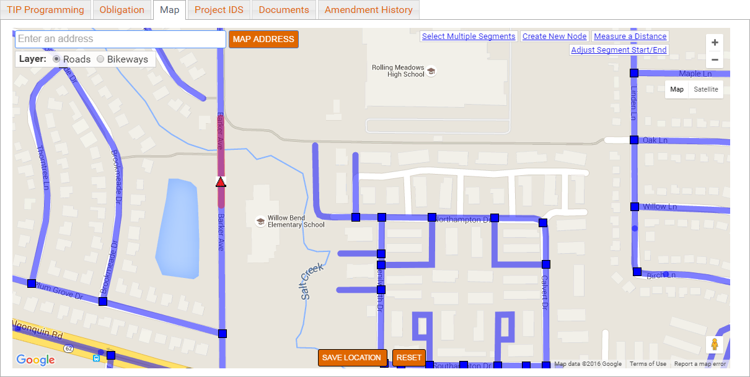
To map a project, zoom in to the exact location until the blue segment lines and nodes are displayed and click on appropriate line segments and/or nodes with which the project is associated. Select “Bikeways” layer for off-road bicycle projects and the “Roads” layer for all other projects. The following are important attributes of the mapping application:

- In the “Bikeways” layer, purple lines represent off-road bicycle paths.
- In the “Roads” layer, dark blue lines represent road segments, dark blue squares represent intersections.
- In the “Roads” layer, light blue triangles represent bridges or structures and are often not located precisely on top of the water or other feature crossed. When in doubt about a bridge location, it can be verified using IDOT's Bridge Information System Search page. Since the IDOT bridge file is the same for both eTIP and the IDOT page, the bridges will be located in the same place.
- In the “Roads” layer, light blue circles represent transit facilities including public rail/highway and rail/pedestrian at grade and rail-over crossings, CTA bus garages and rail stations, and Metra stations. Facilities that are within 100 feet of an existing roadway node (square) are not included. Users should select the roadway node in these cases.

Linear (from/to) projects should be marked as segments. If additional specific work is also being done at a structure or intersection along the segment, those point features should also be selected. For projects that consist of multiple point features, with no work on the segments in between, each point should be selected, rather than the segment.

Segments and points will turn red when selected. When finished mapping, users should click the "Save Location" button. To clear the current map, and any saved changes, click the "Reset" button.

IMPORTANT! It is very important to zoom in to ensure all appropriate segments, nodes, and/or features are selected. The segments align with IDOT’s IRIS files and CMAP’s model network. Only selected segments will be used to develop scores for location-based criteria. For projects that cannot be mapped in eTIP (such as new/extended roads or transit lines), CMAP may request shapefiles and additional information, if available, from the project applicant in order to represent the project in the region’s network.

Some additional map features include:
- Select Multiple Segments
Click-and-drag to select road segments within a rectangle.
  - Allows users to select many road segments in a single area at one time
  - CAUTION: Only segments completely contained within the box will be selected.
  - If segments that are not included within the project are selected, clicking on them individually will unselect them.

- Create New Node
Click on a road to create a new node at that location.
  - Allows users to add new nodes where needed
  - CAUTION: New nodes should be used sparingly, as the underlying segment data will not be automatically split at the new node.

- Measure a Distance
Click on the map to start the measure, then each subsequent click provides the distance, in feet (under 1 mile) or miles, from the previous location clicked. The total distance is displayed in the top left corner of the map. For distances displayed in feet, users can determine the length in miles by dividing the number of feet displayed by 5,280. The user can remove previous segments by clicking “Remove Previous Segment” or can clear the measurement by clicking "Clear Distance Measurement".
  - Allows users to measure project lengths to provide accurate location information on the TIP Programming tab.

- Adjust Segment Start/End
In some cases, the segments on the map may not start/end at a project limit. The Adjust Segment Start/End link can be used to decrease the length of a selected segment. Click the segment to that needs to be modified (the segment to modify must already be selected on the map before clicking “Adjust Segment Start/End”) then click and drag the marker to adjust the length of the segment (the markers must be placed on an existing roadway) to match the project limit. Note that segments can only be shortened, not lengthened.

Uploading Project Documents
At the top of the project creation page, users may click the “Upload Project Documents” link to upload documents associated with the project upon creation. Once a project is created, click the “Documents” tab to begin the document upload process.

To upload a new document, click the cloud icon on the far right side of the page to unhide/hide the “Upload Project Documents” options, as illustrated in Figure 27. From there, enter information related to the document including the date of the document and a description. Then select the document type from the drop-down list and click “Choose File”. Figure 28 lists the CFP document types. Users may upload up to six documents at a time, however for best results, particularly with larger files (> 1MB), upload documents one at a time. When all documents have been chosen, click “Upload Selected”. It is recommended that files that are larger than 5MB be broken into multiple attachments. Users should add a sequencing number to the Document Description for split files.
Figure 27. Click the cloud icon to upload documents associated with the project.
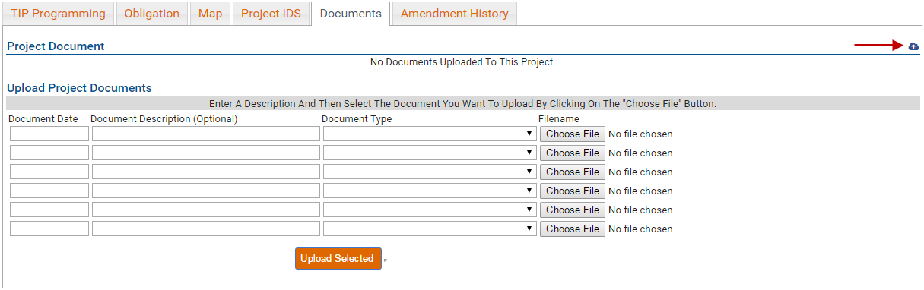
Note: The eTIP system needs the project descriptions to be unique so it can differentiate between them, otherwise the upload may be unsuccessful. If two or more documents are needed, please rename each of them, and the system will save the documents types without an issue.
Figure 28. Document Types
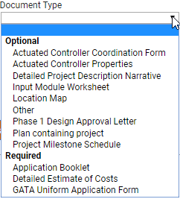

Note that all applications must include the documents in the “Required” list. Some applications, depending on type, must also include documents in the “Optional” list. A location map is only required if the project could not be mapped within the eTIP database. Refer to the Program Application Booklets on the Call for Projects page for more information regarding requirements by application type.

Data Validation and Error Messages
A series of data validations occur when the user clicks the “Save”, “Save as Final” or “Submit” button, including checks for complete and logical data.

Data Validation Errors
If any data validations fail, error messages will be displayed. Project applications can be saved but cannot be submitted to CMAP until all error messages are addressed. Error messages will be displayed in a beige box at the top of the application form and affected fields will be highlighted in yellow.
Figure 29. Data validation in eTIP results in alerts and highlighted fields in the programming form, indicating the exact errors to be addressed.

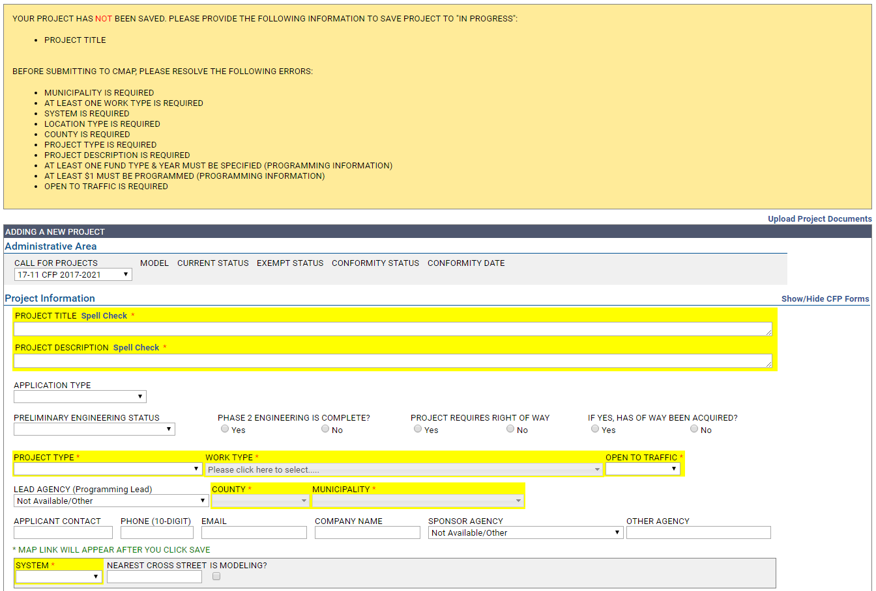

Server Errors
From time to time, server errors occur. Generally, these errors are not caused by user actions.
Figure 30. An example of a server error message, indicating an error in the database. Contact eTIP Help.
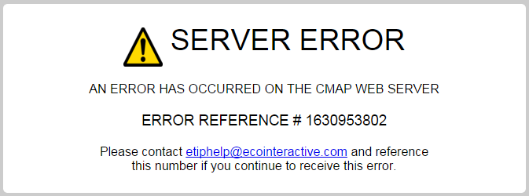

Resource cannot be found: There is an error in the web address (URL) or the web page does not exist or is not available. Check your browser’s address bar and correct any obvious mistakes (cmap.com verses cmap.gov, for example). Refresh the web page. Notify CMAP staff if the error continues.
Figure 31. A different server error, indicating the page does not exist. Contact CMAP staff.

If you receive a server error, please report it to CMAP as soon as possible. Include a screen shot of the error, and a description of what action you were attempting when you received the error.

Additional Resources

More information about the Call for Projects is available here:
https://www.cmap.illinois.gov/mobility/strategic-investment/regional-transportation-programs/call-for-projects

Resources such as Work Types and Fund Sources are available here:
https://www.cmap.illinois.gov/programs/tip/tip-programmer-resources
A list of municipalities by council, which includes Planning Liaison contact information is available here:
https://www.cmap.illinois.gov/documents/10180/33012/Municipalities+by+Council+1-11-19.pdf/c0d06bbe-8210-3248-2ca2-c2e621c77d41

CMAP Staff Contacts
CMAQ and TAP STP Shared Fund
Doug Ferguson Kama Dobbs
312-386-8824 312-386-8710
dferguson@cmap.illinois.gov kdobbs@cmap.illinois.gov

Information for Current eTIP Users
CFP related features for current users, including planning liaisons, CDOT, County, IDOT, and transit agency users that differ from those described throughout this document are explained below.

Home Page: CFP project status
The status of CFP related projects is included in the lists on your home page. These projects are listed separately from on-going TIP amendments as shown in Figure 32. The status and list functionality is the same as a regular TIP amendment.

Figure 32. CFP Projects on the Home Page.
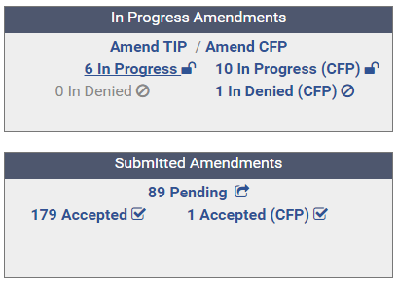

Project Tools: My CFP List
My CFP List has been added to your Project Tools menu. This list functions the same as your My Projects List, but only contains CFP related projects. Note that unfunded CMAQ/TAP applications from the prior application cycle will be included in this list. The current cycle is listed as TIP 20-21.

Starting a New Application
Current users may complete applications on behalf of their agency, or in the case of the Councils, on behalf of a member agency. New applications can only be started by clicking on the “Amend CFP” link in the In Progress Amendments box on the Home Page. Because you have edit rights for your agency, you may Submit applications without “Saving as Final”.

Reviewing and Submitting Applications
Planning liaisons are responsible for reviewing local agency applications for completeness and submitting only complete applications to CMAP for funding consideration. CDOT, County, IDOT, and transit agency users may also be responsible for reviewing and submitting applications for their agency if any “CFP users” were added for their agency. For these agencies, CMAP staff will consult with current users prior to granting additional editing rights to new users and will notify current users of any CFP users that were added to eTIP.

Complete applications should only be submitted to CMAP if they were completed by you, or “Saved as Final” by a local agency or CFP user from your agency. See the appropriate Program Application Booklet on the Call for Projects page for guidance on requirements for each application type.

If an application is incomplete, you may “unsubmit final” to release it back to the applicant/CFP user. Please establish an appropriate deadline by which they should re-submit a complete application in order for you to have time to review and submit that application prior to the application deadline. All complete applications must be submitted to CMAP by the March 15, 2019 application deadline.

System Notifications
You will receive a notification email with the subject “PROJECT <number> in 20-21 - CFP 2020-2024 has been Saved As Final by <user>” whenever a project with your programming Lead Agency is “saved as final” by an applicant.
Figure 33. To review the application, open your In Progress (CFP) list from the home page and look for Save As Final in the CFP Status Column.

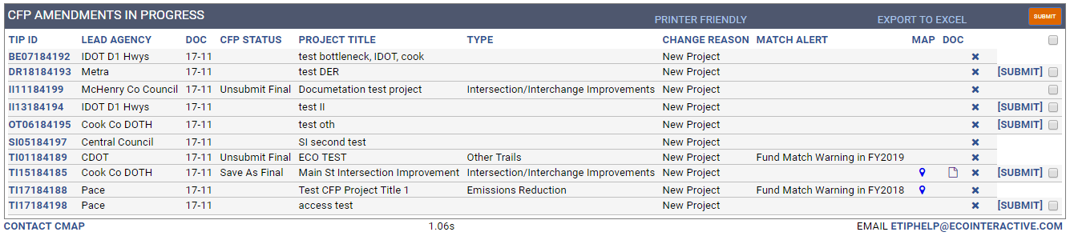

After review, click on the Submit button to forward the application to CMAP. Applicants will be notified that you have submitted the project.

